F.A.B
(Family Activities, Barton Hill)
Summer Family Trips
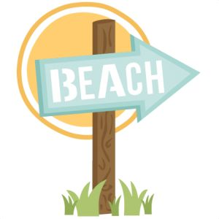
WEYMOUTH BEACH
THURSDAY 10TH AUGUST

TORQUAY BEACH
FRIDAY 1ST SEPTEMBER

ADULTS £10
CHILDREN £6

REGISTRATION IN RECEPTION AT BARTON HILL SETTLEMENT ON:
SATURDAY 1ST JULY and WEDNESDAY 5th JULY
10AM -12PM

Important information:
- £5 per person deposit to be paid on booking, and full payment by Wednesday 26TH July 10 - 12pm for WEYMOUTH and 16th August 10 – 12pm for TORQUAY
- All children must be accompanied by a parent/carer or adult aged 18 or over.
- For families from Lawrence Hill and Easton wards and Redfield
- You can only register your own children or children in your care
- Trips leave Barton Hill Settlement at 8am and leave the beach at 5pm to return

Barton Hill Settlement, 43 Ducie Road, Barton Hill, Bristol BS5 0AX Tel/Fax - 0117 955 6971
Email - admin@bartonhillsettlement.org.uk Website - www.bartonhillsettlement.org.uk
Charity Number 1103139 Limited company no. 5031499

