NEWSLETTER OCTOBER 2019

C:\Users\Teacher\AppData\Local\Microsoft\Windows\Temporary Internet Files\Content.IE5\RW46BKUG\MC900356163[1].wmf

ST PHILIP’S MARSH NURSERY SCHOOL

The children are settling in well and there is a lovely atmosphere around the School.

**Colour and light**

After half term we will be working with the children on the theme of colour and light. The children will be learning about autumn and seasonal changes, bonfires and fireworks and the Christian celebration of Christmas. The children will also be learning about mixing colours and experimenting with a range of art techniques.



**Primary School Applications**

Please remember that the deadline for applying for a Reception Class place for your child is 15 January 2020. The Council are requesting that this is carried out on line where possible at [www.bristol.gov.uk/schooladmissions](http://www.bristol.gov.uk/schooladmissions). Please record your choices on the sheet in your child’s class.

James Britton from the LA (School Admissions) will be running an advice session for parents at **2:30 pm on 18 November** at St Philip's. The brief presentation will cover:

* How to apply
* Information available to help your choice
* The importance of making 3 choices
* What happens if you miss out?
* The pointlessness of appealing (in most cases)
* Deferral and delay

**Car park and child safety**

Your child’s safety is our number one priority at all times. We ask you to make sure that this is yours too. Every school in Bristol has an issue with parking and we are no exception. We are fortunate that we have a small car park at the front of the premises that parents can use. This can get very congested and if you are in a hurry it is best to park in a nearby side street. Walking, cycling and lift sharing are all ways in which to reduce congestion.

We encourage everyone to be tolerant and respectful at all times when using the car park.

Please ensure you keep a close eye on your child whilst walking in and out of the school and do not walk through the car park (use the gated pathways to the side of the building). **Please do not park in the car parks of local businesses.**

In order to ensure that all our children are safe and secure in the school we would be grateful if you could observe the following protocol:

* The school doors open at **8.45 am**, **11.45 am**, **12.30 pm** and **3.30 pm**.
* **Please wait outside until a member of staff opens the door** (unless your child attends Breakfast Club).
* **Please wait outside unless you have made a prior arrangement to pick up your child early.** If you have made a prior arrangement, please ensure you sign them out at Reception and tell their Key Person you are taking them.
* **Please do not open the door to anyone.**
* **Please ensure you** **close doors behind you** and **put the safety catches over the gates**.

**Speech and language sessions**

The Speech and Language Therapy Service will be running the following FREE drop-in session at Barton Hill Settlement.

**Tuesday 5 November 1.00-2.30pm**

**School meals price increase**

In accordance with the catering contract under which St Philip's Marsh Nursery School meals are provided by Chartwells (and the pricing review clauses contained within that contract) the new price for a school meal will be **£2.00 from Monday 4 November 2019**.There is also a new menu which is available at Reception.

**Garden volunteers**

We would like to say a big thank you to the volunteers from B&Q who renovated the playhouses in the garden.

**Thank you**

We would like to express our thanks to Luigi Armato (Vinnie’s dad) who supplied the school with 30 pumpkins. The children have spent the week exploring the inside of the pumpkins and decorating the outside.

**Website**

The School website ([www.stphilipsmarshnursery.co.uk](http://www.stphilipsmarshnursery.co.uk)) is regularly updated and has lots of information about the School, activities the children are engaged in, upcoming events, urgent news, the latest menu and much more! **Please also check out our Facebook page.**

**Donations**

The School provides free milk for all children. We do, however, rely on donations of fruit/vegetables that the children can share at snack time e.g. apples, cucumber, carrots. If you could bring in a small amount each week it would be greatly appreciated. We would also appreciate donations of **boxes of tissues** for the children’s use.

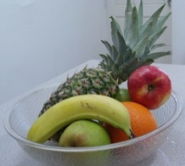

**School Library**

The School library is open. Please use it! The best way you can help your children learn to read is by enjoying reading books with them in a relaxed and comfortable way.

The library is now situated in two places: the School foyer; and in the corridor to the left of Reception. All books are now lent on a trust basis - there is no need to fill in any paperwork, simply borrow the book you would like and return it when you’ve finished. Please feel free to sit and read books before or after school with your child in the library area.

We do, however, encourage you to use a book bag. These can be purchased from the School Office for £2.00. **We are missing books from our library, therefore please could you check at home if you borrowed books last year and forgot to return them.**

**Clothing**

The weather is very changeable at the moment so please ensure your child always brings a coat to school. As the weather gets colder, children will need appropriate clothing and footwear. We go into the garden in all weathers. All clothing and footwear must be labelled. It would be helpful if you could show your child how to put their hats and gloves into the sleeve of their coat when they take them off to prevent them being lost.

Spare clothes may be kept on your child’s peg if needed.

**Sickness**

If your child has sickness and/or diarrhoea please remember that they must stay off school for at least **48 hours** from the last time that they were ill. Also it is the time of year where coughs and colds are occurring. If your child is unwell keep them at home and telephone the School on 0117 977 6171 to report the absence. We can only give prescribed medication at school that has a pharmacist sticker on the bottle or box with your child’s name on it – we cannot give any medicines that you have bought over the counter.

**Froglets and wrap around care**

We still have places for wrap around care (morning and afternoon sessions) and also in breakfast club and after school club. Please see Hazel at Reception if you require a place and the relevant paperwork will be provided.

Children who are due to start wrap around or Froglets for the first time need the paperwork completed in advance of them starting.

Wrap around care is £21.00 per session (am or pm).

Breakfast club is £4.50 per day and includes a healthy breakfast.

After school club is £10.50 per day and includes a hot meal cooked in our school kitchen.

If you are using after school club as part of your 30-hour entitlement, there will be a charge of £2.00 for a hot meal during this session. Alternatively, you can provide a packed lunch.

**Please note – we are currently reviewing our pricing structure for wrap around care, breakfast club and after school club. The new pricing structure will come in to effect in January 2020.**

**Stay and Play Sessions**

We hold ‘Stay and Play’ sessions every Monday and Friday morning in our Family Room. All are very welcome to attend.

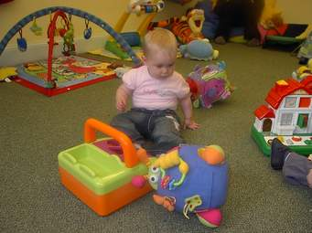

**Forthcoming events**

Half term - School **CLOSED** from **Monday 28 October to Friday 1 November (inclusive)**

School **CLOSED** for INSET day - **Monday 4 November**

Return to school – **Tuesday 5 November**

Speech and Language drop-in - **Tuesday 5 November 1.00-2.30pm** at Barton Hill Settlement

**Monday 18 November** **2.30 pm** – LA Admissions advice session

**Thursday 21 November 9.30 am** – at St Philip’s Marsh Nursery School - Community meeting regarding Temple Quarter Development – further details to follow

C:\Users\SandellM\AppData\Local\Microsoft\Windows\Temporary Internet Files\Content.IE5\PJIBTFA9\MC900440524[1].wmf**Packed Lunches**

**If your child is bringing a packed lunch to nursery  
school please remember the following points:**

* Clearly label your child’s packed lunch box with their name and key group on the outside of the box.
* Remember that many pre-packaged items are adult portion sizes.
  + A child portion size is the size of their fist. A child may only need a half a sandwich – made from one slice of bread. A bag of crisps is an adult portion.
  + Beware hidden sugar. The NHS advice is children should have less than 19g a day for children aged 4 to 6 years old (5 sugar cubes or 5 teaspoons. A single miniature pot of yoghurt may have up 3-4 teaspoons of sugar.
  + Sweets and chocolate are not permitted because they contain unhealthy amounts of sugar.
  + Always include some fruit or fresh vegetables but remember that small tomatoes and grapes are a very common cause of choking in children, and should be cut in half **lengthways**.
* Please do NOT include a drink in your packed lunch. The school provides water for all children (freely available all day). Current dental advice is that children aged 3 to 4 should not drink anything except water from a bottle. Fruit juices or squashes are highly acidic and high in sugar, and so cause serious damage to young teeth.
* Please remember some children have allergies, we therefore request that you **do not** include nuts or nut products, such as Nutella, in your child’s lunch box.
* Please do not include cans or glass bottles/jars in your child’s lunch box.

If you have any queries about packed lunches or any issues relating to food at school or at home please talk to your child’s key person and they will be very happy to help you or introduce you to another team member who can help.

**Thank you for your help.**

At St Philip’s Marsh Nursery School we are committed to safeguarding and promoting the welfare of children and young people. This is our safeguarding team.

 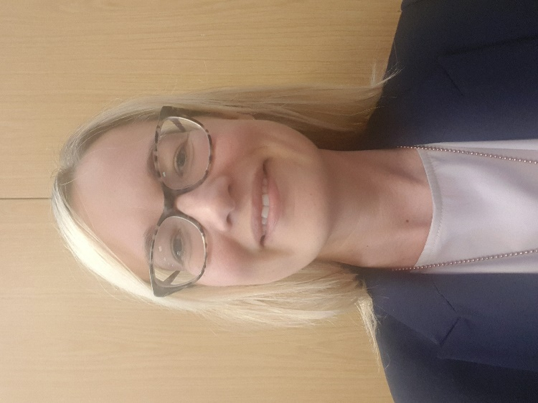

**Simon Holmes – Headteacher Denise Draper – Deputy Headteacher**

**Designated Safeguarding Lead Deputy Safeguarding Lead**

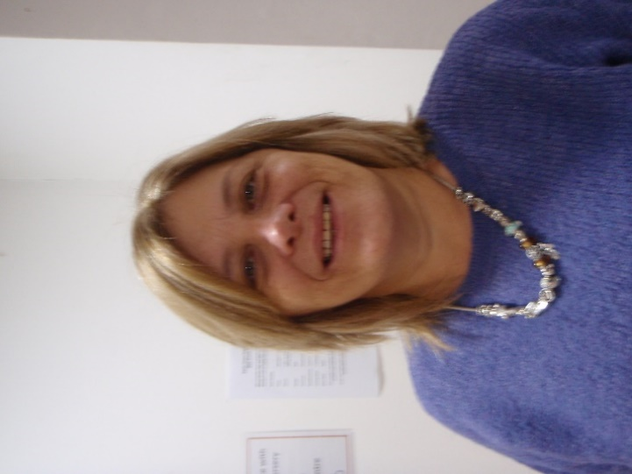 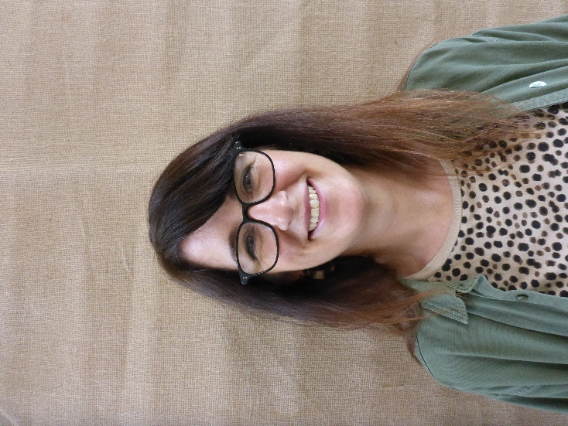

**Sharon Cutler – School Business Manager Tracey Gudonis – Governor**

**Deputy Safegurding Lead Named Safeguarding Governor**