NEWSLETTER JULY 2019

C:\Users\Teacher\AppData\Local\Microsoft\Windows\Temporary Internet Files\Content.IE5\RW46BKUG\MC900356163[1].wmf

ST PHILIP’S MARSH NURSERY SCHOOL

We would like to take this opportunity to say goodbye and good luck to the children leaving us for ‘pastures new’ in July. To the children who will be returning to us in September, we wish you a very happy summer holiday and look forward to welcoming you back at school from Wednesday 4 September.

**Summer safety**

It’s most definitely finally summer! When the sun begins to shine it is important to take certain precautions. Please make sure your child’s shoulders are covered, bring a sun hat (labelled with your child’s name) and, if you think it is necessary, apply sun cream before your child comes to school. It would be difficult for staff to apply sun cream to children due to the number of children attending the setting each day and due to allergies. There are sun creams available that last all day and this would be preferable. However, you can send in sun cream (labelled with your child’s name) and the staff will supervise whilst they apply it themselves. It might be a good idea for them to practice this at home first. Please do not leave sun cream in your child’s bag but ensure it is given to your child’s key person. The children spend a lot of time outside: climbing; riding bikes and scooters; playing ball games; gardening and running around. Open-toed sandals, crocs and flip flops are not suitable footwear and can be dangerous. Please ensure your child wears suitable footwear to School.



**Transition**

Transition arrangements are well underway to prepare children who will be leaving us to start their Reception classes in September. Many of the schools will send their Reception teacher to visit your child in school and there will be opportunities for you and your child to visit their new school for ‘taster’ sessions. Please talk to your child’s key person if you have any concerns.

**‘This is our community’ celebration day -Wednesday 17 July**

Please see attached.

**Staffing and governor update**

We are sad to be saying goodbye to Cherene Roberts. Cherene has been working in our After School Club (Froglets) for the past 4 years. Cherene will be going on to pursue her career in Reiki and well-being therapy. We wish her every success.

**Wrong Trousers Day**

Thank you for participating in Wrong Trousers Day on Friday 28June. There were some wonderful examples of crazy trousers/shorts/ pyjamas. We raised the grand total of £23.00 which will go to The Grand Appeal in aid of Bristol Children’s Hospital and Neonatal Unit.



**ZooLab**

ZooLab UK will be visiting the School on Monday 8 July. The visit will entail the showing and handling of live animals and all the children will get the opportunity to handle some of the animals themselves.

**Dinner money**

It is extremely helpful if dinner money is paid weekly in advance by cheque (made payable to Bristol City Council) or cash. The administration of dinner money is very time consuming and the School is not allowed to carry arrears.  Arrears have to be paid for out of the School’s limited budget, which takes money away from the children’s educational needs. If you are in receipt of certain benefits you may be entitled to free school meals. Please ask at Reception for further information.

**Please give your payment to Hazel/Maggie at Reception. If the desk is unmanned, please ensure you give the payment to a member of staff.**

**Mayoral visit**

We were delighted to welcome Councillor Margaret Hickman and Marvin Rees (Mayor of Bristol) to the School recently.

He later tweeted:

“*@Marg Hickman and I enjoyed our I enjoyed our visit to St Philip’s Marsh Nursery & Cashmore EYC. Pleased that plans for nearby gas power station were stopped - Thanks to the amazing staff for their work to ensure children have the best start in lifeI enjoyed our visit to St Philip’s Marsh Nursery & Cashmore EYC. Pleased that plans for nearby gas power station were stopped - Thanks to the amazing staff for their work to ensure children have the best start in life.visit to St Philip’s Marsh Nursery and Cashmore EYC. Pleased that plans for nearby gas power station were stopped. Thanks to the amazing staff for their work to ensure children have the best start in life.*”

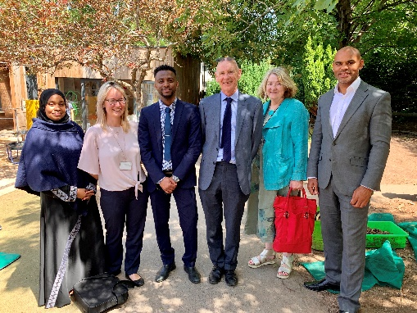

**Yoga**

The children have been doing some yoga sessions with Lottie Park. Lottie is a fully trained children’s yoga teacher from ‘Grow and Glow’. Yoga is known to be beneficial for physical and mental well-being. Lottie delivers her sessions in a playful and mindful way. The children are loving it.

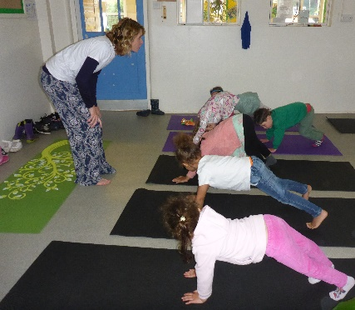

**INSET Days**

The School will be **CLOSED on Monday 2 and Tuesday 3 September**.

**Important dates**

Zoolab – **Monday 8 July**

“This is Our Community” celebration day – **2.00 pm Wednesday 17 July**

Sing-alongs:  
**Friday 19 July - 9.15 am** and  
**Tuesday 23 July - 2.30 pm**

**24 July – 30 August** (inclusive) – School CLOSED for summer holidays

INSET day – **Monday 2 and Tuesday 3 September** – (**SCHOOL CLOSED**)

Return to school – **Wednesday 4 September**



**St Philip’s Marsh Nursery School, Barton Hill Children’s Centre, Cashmore Early Years Centre**

**‘This is our community’ celebration day**



**Wednesday 17 July 2019**

On Wednesday 17 July we are having a ‘This is our community’ celebration day at St Philip’s. ‘Mandinka Roots’, a Senegalese drumming group will be doing storytelling, singing, drumming and dancing with the children. The day will end with a drumming/dance celebration in the garden (weather permitting). All children and their parents/carers are invited at **2:00pm** to join in. If the weather is bad we will have the celebration indoors.

We need **volunteers** to help out on the day with various craft workshops e.g. face painting, necklace making, cutting up fruit etc. If you are able to help please see your child’s key person.

**We would be very grateful for any donations of tropical fruit or juices for the day.**

We hope you enjoy the celebration!