NEWSLETTER OCTOBER 2018

C:\Users\Teacher\AppData\Local\Microsoft\Windows\Temporary Internet Files\Content.IE5\RW46BKUG\MC900356163[1].wmf

ST PHILIP’S MARSH NURSERY SCHOOL

The children are settling in well and there is a lovely atmosphere around the School.

**Colour and light**

After half term we will be working with the children on the theme of colour and light. The children will be learning about autumn and seasonal changes, bonfires and fireworks and the Christian celebration of Christmas. The children will also be learning about mixing colours and experimenting with a range of art techniques.



**Primary School Applications**

Please remember that the deadline for applying for a Reception Class place for your child is 15 January 2019. The Council are requesting that this is carried out on line where possible at [www.bristol.gov.uk/schooladmissions](http://www.bristol.gov.uk/schooladmissions). Please record your choices on the sheet in your child’s class.

**Safety**

Your child’s safety is our number one priority at all times. We ask you to make sure that this is yours too. Every school in Bristol has an issue with parking and we are no exception. We are fortunate that we have a small car park at the front of the premises that parents can use. This can get very congested and if you are in a hurry it is best to park in a nearby side street. Walking, cycling and lift sharing are all ways in which to reduce congestion. Please ensure you keep a close eye on your child whilst walking in and out of the school and do not walk through the car park (use the gated pathways to the side of the building). **Please do not park in the car parks of local businesses.**

In order to ensure that all our children are safe and secure in the school we would be grateful if you could observe the following protocol:

* The school doors open at **8.45 am**, **11.45 am**, **12.30 pm** and **3.30 pm**.
* **Please wait outside until a member of staff opens the door** (unless your child attends Breakfast Club).
* **Please wait outside unless you have made a prior arrangement to pick up your child early.** If you have made a prior arrangement, please ensure you sign them out at Reception and tell their Key Person you are taking them.
* **Please do not open the door to anyone.**
* **Please ensure you** **close doors behind you** and **put the safety catches over the gates**.

.

**Speech and language sessions**

The Speech and Language Therapy Service will be running the following FREE drop-in session at Barton Hill Settlement.

**Thursday 8 November 10-11 am**

**School meals price increase**

In accordance with the catering contract under which St Philip's Marsh Nursery School meals are provided by Chartwells (and the pricing review clauses contained within that contract) the new price for a school meal will be **£1.95 from Monday 5 November 2018**.

**St Philip’s Marsh Open Day**

Thank you to past and present pupils and parent/carers who attended St Philip’s Marsh Open Day on Sunday 30 September to celebrate the past, present and future of ‘the Marsh’. Exhibitions and entertainment at the St Silas Royal British Legion drew great crowds and the open bus tour was very successful (even if a little chilly!). Thank you also for supporting the tea/cake sale we held at the Nursery at which we raised £92 for school funds.

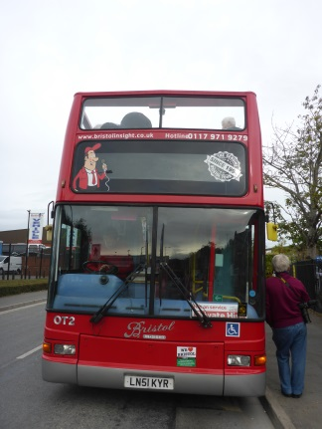

**Garden volunteers**

We are fortunate to be part of Royal Botanic Gardens at Kew’s Grow Wild Autumn wildflower campaign. As a result, we have been given a kit containing wildflower seed mixes. To give the seeds the best chance at growing we think our garden needs a bit of an overhaul. We would be extremely grateful if anyone is able to help us with digging and weeding. Thanking you in anticipation.

**Website**

The School website ([www.stphilipsmarshnursery.co.uk](http://www.stphilipsmarshnursery.co.uk)) is regularly updated and has lots of information about the School, activities the children are engaged in, upcoming events, urgent news, the latest menu and much more! **Please also check out our Facebook page.**

**Donations**

The School provides free milk for all children. We do, however, rely on donations of fruit/vegetables that the children can share at snack time e.g. apples, cucumber, carrots. If you could bring in a small amount each week it would be greatly appreciated. We would also appreciate donations of **boxes of tissues** for the children’s use.

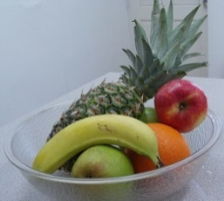

**School Library**

The School library is open. Please use it! The best way you can help your children learn to read is by enjoying reading books with them in a relaxed and comfortable way.

The library is now situated in two places: the School foyer; and in the corridor to the left of Reception. All books are now lent on a trust basis - there is no need to fill in any paperwork, simply borrow the book you would like and return it when you’ve finished. Please feel free to sit and read books before or after school with your child in the library area.

We do, however, encourage you to use a book bag. These can be purchased from the School Office for £2.00. **We are missing books from our library, therefore please could you check at home if you borrowed books last year and forgot to return them.**



**Clothing**

The weather is very changeable at the moment so please ensure your child always brings a coat to school. As the weather gets colder, children will need appropriate clothing and footwear. We go into the garden in all weathers. All clothing and footwear must be labelled. It would be helpful if you could show your child how to put their hats and gloves into the sleeve of their coat when they take them off to prevent them being lost.

Spare clothes may be kept on your child’s peg if needed.

**Sickness**

If your child has sickness and/or diarrhoea please remember that they must stay off school for at least **48 hours** from the last time that they were ill. Also it is the time of year where coughs and colds are occurring. If your child is unwell keep them at home and telephone the School on 0117 977 6171 to report the absence. We can only give prescribed medication at school that has a pharmacist sticker on the bottle or box with your child’s name on it – we cannot give any medicines that you have bought over the counter.

**Hand, foot and mouth**

We have had one confirmed case of hand, foot and mouth in the School.

Please speak to a member of staff/phone the School if you suspect that your child has been affected.

Further information can be found [https://www.nhs.uk/conditions/hand-foot-mouth-disease/](https://l.facebook.com/l.php?u=https%3A%2F%2Fwww.nhs.uk%2Fconditions%2Fhand-foot-mouth-disease%2F&h=AT3C7KLg5hhrFXe128Xih6w0soKOqzWUpFK7Qd_mFFnQV1AgTvdBuMMnCX_3vtTii3FV2N4bJny0Gsi3k0lHFPqHjRW9XX3jU8Hjf5-nYXhiWZpvvrg_LKzEW4WSa3zvY3_kSoiLCRBArs1L6uhIhCGscliWsWT6rWFcQd6T2GiH3fVM1BYqzF2C4zvCczlXTyPqKwrknyDHS22oLrzrQYpdYTcxMXpBa8dVo7sM58qaHU92G4v5pkiMTNI709acUK2mRzYM4fvDWXYs3LReEBHZ_drcvKet-lXW_lt1rChNDdlSuL0foR_d-lmzPyfsMJd2KQ2sTCqoaJ71Gjukpskh506aUm_wXbxJK8k8lfaDx1C4ONgeVTMhyW31ZqEDqozLdxH_ZGgu8Lhr5YtzNOZiNtQG51y4)

**Froglets and wrap around care**

We still have places for wrap around care (morning and afternoon sessions) and also in breakfast club and after school club. Please see Hazel at Reception if you require a place and the relevant paperwork will be provided.

Children who are due to start wrap around or Froglets for the first time need the paperwork completed in advance of them starting.

Wrap around care is £21.00 per session (am or pm).

Breakfast club is £4.50 per day and includes a healthy breakfast.

After school club is £10.50 per day and includes a hot meal cooked in our school kitchen.

If you are using after school club as part of your 30 hour entitlement, there will be a charge of £1.95 for a hot meal during this session. Alternatively you can provide a packed lunch.

**Stay and Play Sessions**

We hold ‘Stay and Play’ sessions every Monday and Friday morning in our Family Room. All are very welcome to attend.

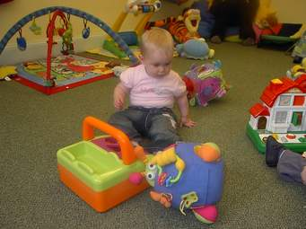

**Forthcoming events**

The School will be **CLOSED** for half term from **Monday 29 October to Friday 2 November (inclusive)**.

The School will also be **CLOSED** for INSET day on **Monday 5 November**.

Return to School on **Tuesday 6 November**.

St Philip’s Marsh Nursery School

bags £1,983.00

from Tesco’s community grant scheme

St Philip’s Marsh Nursery School is delighted to announce it has bagged £1,983.00 from Tesco’s Bags of Help community grant scheme. Thank you to the thousands of shoppers who voted for us at Tesco stores in South Bristol during July and August. Work will now begin on bringing our sensory play space to life.

Bags of Help is run in partnership with environmental charity Groundwork and sees grants raised from the sale of carrier bags awarded to thousands of local community projects every year. Since launching in 2015, it’s provided more than £60 million to over 18,000 local community projects.

Alec Brown, Tesco’s Head of Community, said:

“Bags of Help has been a fantastic success and we’ve been overwhelmed by the response from customers. It’s such a special scheme because it’s local people who decide how the money will be spent in their community. We can’t wait to see the projects come to life.”

Groundwork’s National Chief Executive, Graham Duxbury, said:

“Bags of Help continues to enable local communities up and down Britain to improve the local spaces and places that matter to them. The diversity of projects that are being funded shows that local communities have a passion to create something great in their area. We are pleased to be able to be a part of the journey and provide support and encouragement to help local communities thrive.”

