

C:\Users\Teacher\AppData\Local\Microsoft\Windows\Temporary Internet Files\Content.IE5\YYAQUE2W\MC900445712[1].wmfC:\Users\Teacher\AppData\Local\Microsoft\Windows\Temporary Internet Files\Content.IE5\YYAQUE2W\MC900445712[1].wmfC:\Users\Teacher\AppData\Local\Microsoft\Windows\Temporary Internet Files\Content.IE5\YYAQUE2W\MC900445712[1].wmf

St Philip’s Marsh Nursery School

FROGLETS

St Philips Marsh Nursery School

FROGLETS

**What is Froglets Club?**

We provide high quality, exciting before and after school care for our children in the Family Room at St Philip’s Marsh Nursery School. The children gave it the name “Froglets”.

**What are the opening and closing times?**

Breakfast Club starts at 7.45 am and children will be taken to their classrooms at 8.45 am.

After School Club starts at 3.15 pm. The children will be collected by staff from their classrooms and taken to After School Club. They must be collected by a parent/carer **no later than 5.45 pm**.

**What if I need to cancel my child’s place?**

If your child is ill or absent for a few days, you will be expected to pay for their regular sessions. If you wish to end your child’s regular sessions before the end of term, we ask for one month’s prior notice.

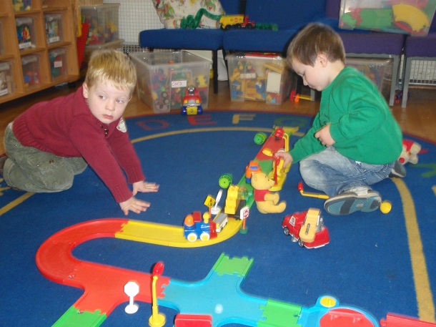

**What will my child do in Froglets?**

Breakfast Club

When the children arrive in the morning they will be given a healthy breakfast. They will then be able to play until it’s time to go to class.

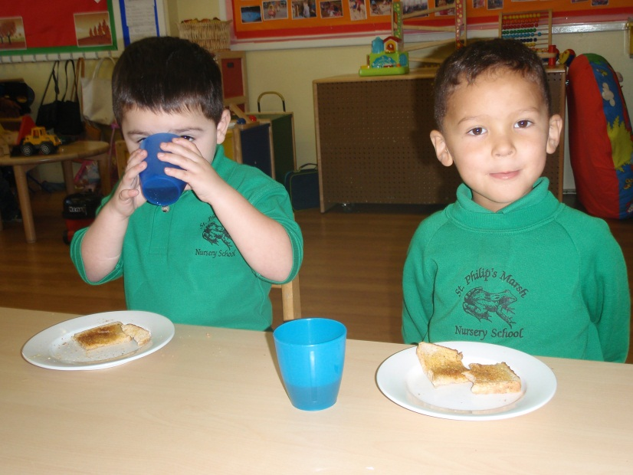

After School Club

The children will be able to play until it’s time for tea. After a healthy tea, children can choose free play or take part in an adult-organised activity e.g. cookery, painting. At 5.30 pm the children will be able to engage in a relaxing activity e.g. listening to a story, singing or, occasionally, a DVD.

**Who will look after my child?**

Froglets staff are qualified and experienced in order to maintain the high quality of care that the School provides. Some of the Froglets staff work in the classrooms during the day and therefore will be familiar to the children. Each session is run by Play Workers.

**What will my child eat?**

The School believes in promoting healthy lifestyles and therefore the children are offered a healthy meal during each session. For Breakfast Club this includes toast, yoghurt, fruit and cereal. The After School Club meal is cooked on site, details of which are displayed in the Family Room. If a child has special dietary requirements, this will be catered for.

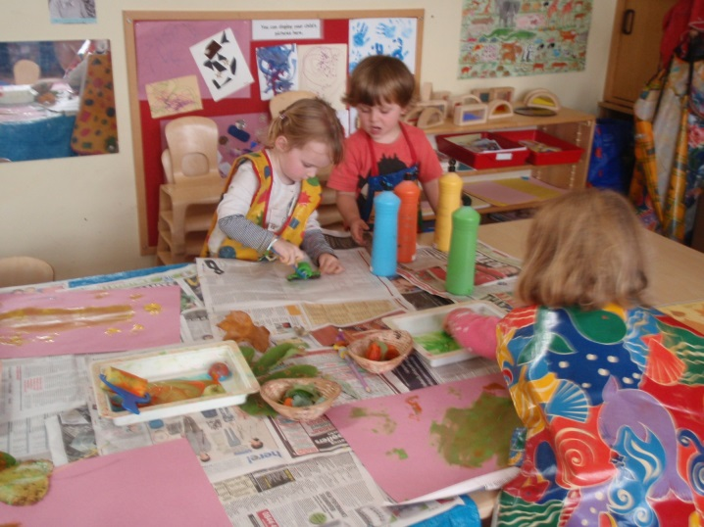

**How will I know my child is safe?**

Froglets is run under the guidance of the School’s Health & Safety Policy and Child Protection Policy. The building has secure gates, coded door pads, monitors and cameras to protect the premises.

**Who can use Froglets?**

Froglets is intended to be an inclusive and accessible service for all children in the School. Places are allocated on a first come, first served basis.

**How much does it cost?**

Breakfast Club costs £3.50 per session and After School Club costs £9.50 per session. One month’s notice will be given to parents/carers regarding price changes.

**How do I pay?**

Parents/carers will be given monthly invoices in advance. Invoices must be paid within 14 days either by cash or cheque or payment can be made to Bristol City Council, details of which are printed on the bottom of each invoice. We also welcome childcare vouchers from several companies (please see Reception for further information).

**Will I have to book in advance?**

Yes. We ask parents to book regular monthly sessions.

**Can I get help with fees?**

Unfortunately, we cannot offer subsidised places. However, if you are working over 16 hours per week, you may be entitled to Child Care Tax Credits which can cover up to 70% of the cost. If you are studying or looking for work, there may be bursaries or grants

available. We can offer practical support to parents who want to make claims – please speak to Reception for further information.

**How do I book a place for my child?**

Registration forms are available from Reception. Please complete and return the form as soon as possible. Places are allocated on a first come, first served basis.

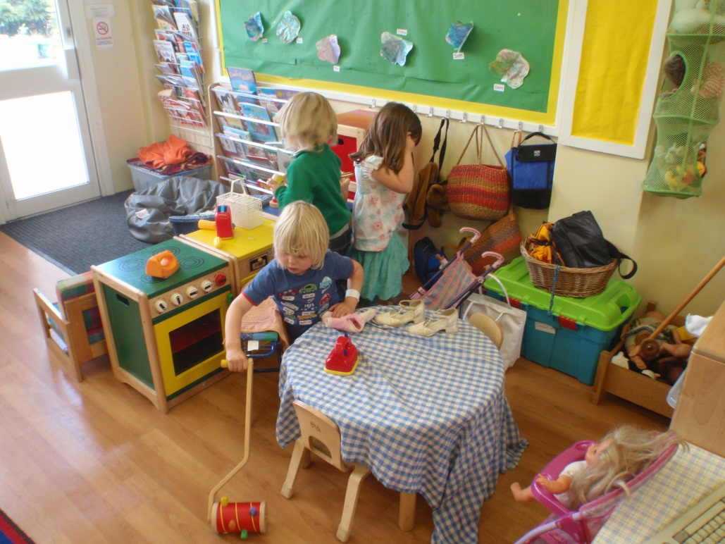

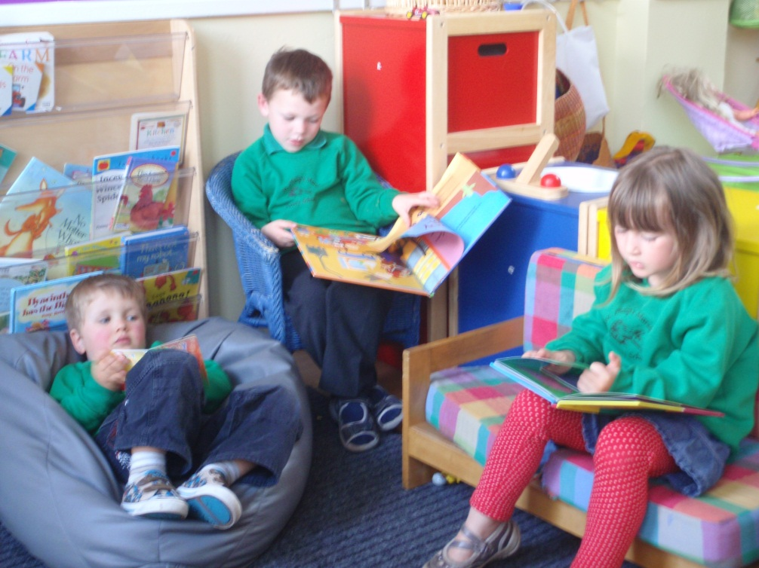

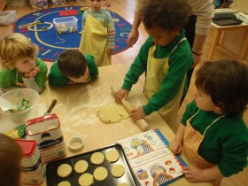

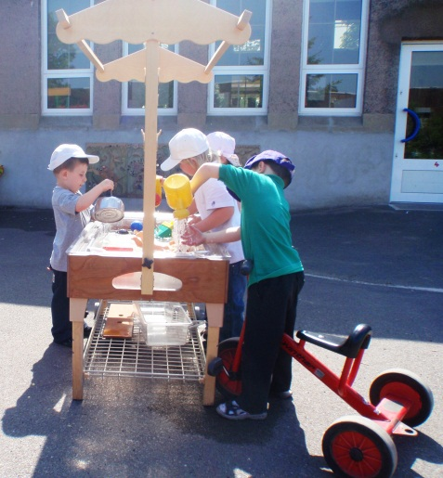

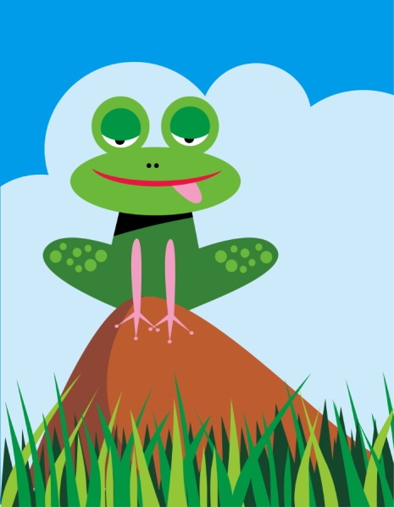

**We look forward to welcoming your child to Froglets soon**